
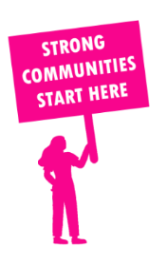
THE VALUE OF NEIGHBOURHOOD HOUSES IN EUREKA IN 2024

Neighbourhood Houses are the Hearts of their Communities.
16,512 visits
189 volunteers
151 jobs
Value to the electorate
per $1 of income:
$4.87
Community value provided:
$8,502,300
Here’s what participants reported:
93% said the activity they participated in had a positive or very positive impact on their emotional wellbeing,
98% said the activity they participated in had a positive or very positive impact on their physical wellbeing
96% said the activity they participated in had a positive or very positive impact on their social connections.
56% participants became more involved in community activities outside of a Neighbourhood House
74% said the activity they participated in had a positive or very positive impact on their sense of belonging.

57
community groups supported
2,954
Sessions across 5 Neighbourhood Houses
4,224 KGS
in food relief
27
NHCP funded hours/week on average
660
Hours connecting people to gov services

Neighbourhood Houses in Eureka
Ballan & District Community House
Ballarat East Neighbourhood House
Darley Neighbourhood House & Learning Centre
Laurels Education and Training
Meredith Community Centre

