
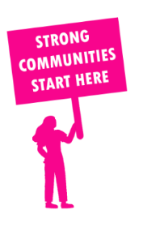
THE VALUE OF NEIGHBOURHOOD HOUSES IN ESSENDON IN 2024

Neighbourhood Houses are the Hearts of their Communities.
16,128 visits
90 volunteers
74 jobs
Value to the electorate
per $1 of income:
$5.99
Community value provided:
$16,782,954
Here’s what participants reported:
88% said the activity they participated in had a positive or very positive impact on their emotional wellbeing,
97% said the activity they participated in had a positive or very positive impact on their physical wellbeing
98% said the activity they participated in had a positive or very positive impact on their social connections.
59% participants became more involved in community activities outside of a Neighbourhood House
82% said the activity they participated in had a positive or very positive impact on their sense of belonging.

24
community groups supported
4,646
Sessions across 2 Neighbourhood Houses
18,000 KGS
in food relief
40
NHCP funded hours/week on average
672
Hours connecting people to gov services

Neighbourhood Houses in Essendon
Farnham Street Neighbourhood Learning Centre
Wingate Avenue Community Centre
Somali Women's Development Association Inc. (Unfunded)

