
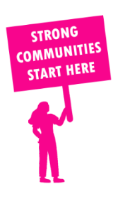
THE VALUE OF NEIGHBOURHOOD HOUSES IN EILDON IN 2024

Neighbourhood Houses are the Hearts of their Communities.
28,704 visits
479 volunteers
395 jobs
Value to the electorate
per $1 of income:
$2.52*
Community value provided:
$11,768,585*
Here’s what participants reported:
95% said the activity they participated in had a positive or very positive impact on their emotional wellbeing,
97% said the activity they participated in had a positive or very positive impact on their physical wellbeing
97% said the activity they participated in had a positive or very positive impact on their social connections.
64% participants became more involved in community activities outside of a Neighbourhood House
81% said the activity they participated in had a positive or very positive impact on their sense of belonging.

109
community groups supported
9,203
Sessions across 12 Neighbourhood Houses
30,876 KGS
in food relief
23.1
NHCP funded hours/week on average
2,052
Hours connecting people to gov services

Neighbourhood Houses in Eildon
Alexandra Community Hub
Allwood Neighbourhood House
Bonnie Doon Community Centre
Cire Yarra Junction Community Hub
Flowerdale Community House
Healesville Living & Learning Centre
Kinglake Ranges Neighbourhood House
Living and Learning Nillumbik - Panton Hill (Unfunded)
Mansfield Adult Continuing Education Centre
Toolangi Castella District Community House
Wadambuk St Andrews Community Centre (Unfunded)
Woori Community House
Yarra Glen & District Living & Learning Centre (Unfunded)
Yea Community House

* Income and value to electorate from Cire Services excluded due to their size and complexity of collecting all necessary data

