
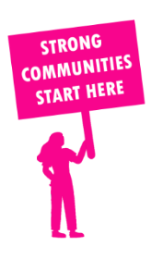
THE VALUE OF NEIGHBOURHOOD HOUSES IN KEW IN 2024

Neighbourhood Houses are the Hearts of their Communities.
12,696 visits
43 volunteers
35 jobs
Value to the electorate
per $1 of income:
$5.44
Community value provided:
$5,723,874
Here’s what participants reported:
94% said the activity they participated in had a positive or very positive impact on their emotional wellbeing,
100% said the activity they participated in had a positive or very positive impact on their physical wellbeing
100% said the activity they participated in had a positive or very positive impact on their social connections.
58% participants became more involved in community activities outside of a Neighbourhood House
62% said the activity they participated in had a positive or very positive impact on their sense of belonging.

3
community groups supported
3,918
Sessions across 1 Neighbourhood Houses
120 KGS
in food relief
25
NHCP funded hours/week on average
300
Hours connecting people to gov services

Neighbourhood Houses in Kew
Balwyn Community Centre (Unfunded)
Kew Neighbourhood Learning Centre
Trentwood at the Hub Community House (Unfunded)

