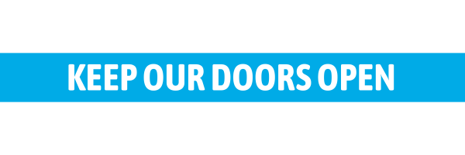
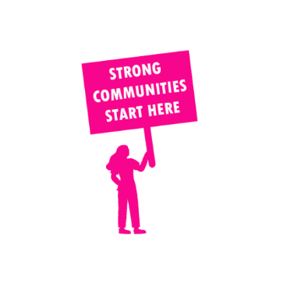
THE VALUE OF NEIGHBOURHOOD HOUSES IN EASTERN VICTORIA REGION IN 2024

Neighbourhood Houses are the Hearts of their Communities.
249,096 visits
2,387 volunteers
742 jobs
Value to the electorate
per $1 of income:
$3.84
Community value provided:
$97,557,289
Here’s what participants reported:
95% said the activity they participated in had a positive or very positive impact on their emotional wellbeing,
97% said the activity they participated in had a positive or very positive impact on their physical wellbeing
95% said the activity they participated in had a positive or very positive impact on their social connections.
58% participants became more involved in community activities outside of a Neighbourhood House
80% said the activity they participated in had a positive or very positive impact on their sense of belonging.

541
community groups supported
55,057
Sessions across 70 Neighbourhood Houses
618,120 KGS
in food relief
25.7
NHCP funded hours/week on average
7,008
Hours connecting people to gov services

Neighbourhood Houses in Eastern Victoria
Lilydale Community House
Mount Evelyn Community House
Seville Community House
Coonara Community House
Mountain District Learning Centre
Olinda Community House
Selby Community House
The Basin Community House
Blind Bight Community Centre
Lang Lang Community Centre
Crib Point Community House
Good Shepherd Community House @ Wallaroo Community Centre
Hastings Community House
Langwarrin Community Centre
Somerville Community House
Willum Warrain Aboriginal Association
Cockatoo Community House
Fernlea Community House
Bentons Square Community Centre
Mornington Community House
Mount Eliza Neighbourhood House
Mount Martha House Community Centre
Bunyip & District Community House
Dromana Community House
Rye Community House
Seawinds Community Hub
Sorrento Community Centre
Living & Learning Pakenham
Outlook Community Centre
Bairnsdale Neighbourhood House
Bemm River District Neighbourhood House
Benambra Neighbourhood House
Bendoc Resource Centre and Neighbourhood House
Briagolong Community House
Bruthen and District Neighbourhood House
Buchan Neighbourhood House
Cann River Community Centre
Community Centre Swifts Creek
East Bairnsdale Community Hub
Heyfield Community Resource Centre
Lakes Entrance Neighbourhood House
Maffra Neighbourhood House
Mallacoota District Health & Support Service Neighbourhood House
Orbost Neighbourhood House
Paynesville Neighbourhood Centre
Segue Community Hub and Arts Cafe
Tubbut Neighbourhood House
Dargo Community House
Omeo Community Hub
Bass Valley Community Centre

Corinella & District Community Centre
Inverloch Community House
Phillip Island Community and Learning Centre
Wonthaggi Neighbourhood Centre at Mitchell House
Gormandale Community House
Leongatha Community House
Loch Sport Community House
Manna Gum Community House
Marley Street Community Hub
Milpara Community House
Rosedale Neighbourhood House
Sale Neighbourhood House
Venus Bay Community Centre
Wurruk Community House
Yarram Neighbourhood House
Churchill Neighbourhood Centre
Moe Neighbourhood House
Morwell Neighbourhood House
Traralgon Neighbourhood Learning House
Warragul Community House

Includes 2 unfunded Neighbourhood Houses

