
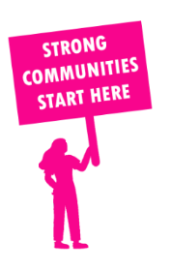
THE VALUE OF NEIGHBOURHOOD HOUSES IN POLWARTH IN 2024

Neighbourhood Houses are the Hearts of their Communities.
31,734 visits
588 volunteers
521 jobs
Value to the electorate
per $1 of income:
$5.21
Community value provided:
$10,834,977
Here’s what participants reported:
93% said the activity they participated in had a positive or very positive impact on their emotional wellbeing,
95% said the activity they participated in had a positive or very positive impact on their physical wellbeing
95% said the activity they participated in had a positive or very positive impact on their social connections.
74% participants became more involved in community activities outside of a Neighbourhood House
84% said the activity they participated in had a positive or very positive impact on their sense of belonging.

99
community groups supported
6,138
Sessions across 11 Neighbourhood Houses
70,920 KGS
in food relief
25
NHCP funded hours/week on average
936
Hours connecting people to gov services

Neighbourhood Houses in Polwarth
Anglesea Community House
Camperdown Community House
Colac Neighbourhood House
Deans Marsh Community Cottage
Forrest Neighbourhood House
Gellibrand Community House
Lorne Community House
Marrar Woorn Neighbourhood House
Simpson and District Community Centre
Torquay Community House
Winchelsea Community House

