
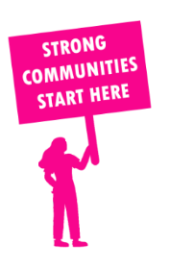
THE VALUE OF NEIGHBOURHOOD HOUSES IN CROYDON IN 2024

Neighbourhood Houses are the Hearts of their Communities.
54,588 visits
149 volunteers
121 jobs
Value to the electorate
per $1 of income:
$3.82
Community value provided:
$17,085,682
Here’s what participants reported:
96% said the activity they participated in had a positive or very positive impact on their emotional wellbeing,
92% said the activity they participated in had a positive or very positive impact on their physical wellbeing
90% said the activity they participated in had a positive or very positive impact on their social connections.
43% participants became more involved in community activities outside of a Neighbourhood House
68% said the activity they participated in had a positive or very positive impact on their sense of belonging.

65
community groups supported
6,335
Sessions across 6 Neighbourhood Houses
33,336 KGS
in food relief
25
NHCP funded hours/week on average
912
Hours connecting people to gov services

Neighbourhood Houses in Croydon
Arrabri Community House
Glen Park Community Centre
Japara Neighbourhood House
Mullum Mullum Indigenous Gathering Place
Yarrunga Community Centre
Mooroolbark Community Centre

