
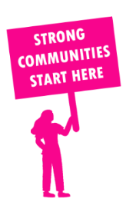
THE VALUE OF NEIGHBOURHOOD HOUSES IN GLEN WAVERLEY IN 2024

Neighbourhood Houses are the Hearts of their Communities.
25,980 visits
73 volunteers
43 jobs
Value to the electorate
per $1 of income:
$3.09
Community value provided:
$4,561,676
Here’s what participants reported:
97% said the activity they participated in had a positive or very positive impact on their emotional wellbeing,
97% said the activity they participated in had a positive or very positive impact on their physical wellbeing
97% said the activity they participated in had a positive or very positive impact on their social connections.
44% participants became more involved in community activities outside of a Neighbourhood House
74% said the activity they participated in had a positive or very positive impact on their sense of belonging.

25
community groups supported
4,496
Sessions across 4 Neighbourhood Houses
n/a KGS
in food relief
25
NHCP funded hours/week on average
96
Hours connecting people to gov services

Neighbourhood Houses in Glen Waverley
Kerrie Neighbourhood House
Mount Street Neighbourhood House
Vermont South Learning Centre
Wavlink Inc.

