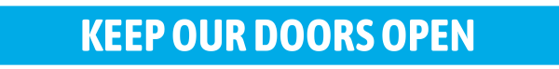
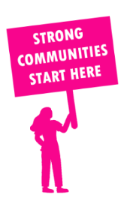
THE VALUE OF NEIGHBOURHOOD HOUSES IN NARRACAN IN 2024

Neighbourhood Houses are the Hearts of their Communities.
3,900 visits
45 volunteers
33 jobs
Value to the electorate
per $1 of income:
$4.79
Community value provided:
$2,177,983
Here’s what participants reported:
96% said the activity they participated in had a positive or very positive impact on their emotional wellbeing,
99% said the activity they participated in had a positive or very positive impact on their physical wellbeing
97% said the activity they participated in had a positive or very positive impact on their social connections.
62% participants became more involved in community activities outside of a Neighbourhood House
87% said the activity they participated in had a positive or very positive impact on their sense of belonging.

16
community groups supported
1,568
Sessions across 2 Neighbourhood Houses
13,656 KGS
in food relief
30
NHCP funded hours/week on average
108
Hours connecting people to gov services

Neighbourhood Houses in Narracan
Bunyip & District Community House
Warragul Community House

