
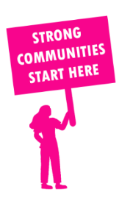
THE VALUE OF NEIGHBOURHOOD HOUSES IN NORTHCOTE IN 2024

Neighbourhood Houses are the Hearts of their Communities.
26,004 visits
132 volunteers
88 jobs
Value to the electorate
per $1 of income:
$2.41
Community value provided:
$6,599,832
Here’s what participants reported:
91% said the activity they participated in had a positive or very positive impact on their emotional wellbeing,
94% said the activity they participated in had a positive or very positive impact on their physical wellbeing
92% said the activity they participated in had a positive or very positive impact on their social connections.
52% participants became more involved in community activities outside of a Neighbourhood House
79% said the activity they participated in had a positive or very positive impact on their sense of belonging.

50
community groups supported
5,802
Sessions across 5 Neighbourhood Houses
13,068 KGS
in food relief
34
NHCP funded hours/week on average
984
Hours connecting people to gov services

Neighbourhood Houses in Northcote
Alphington Community Centre
Bridge Darebin: Thornbury
Gurwidj Aboriginal Women's Neighbourhood House
Jika Jika Community Centre
Span Community House

