
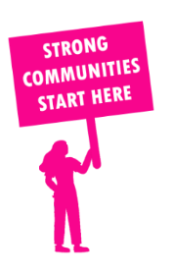
THE VALUE OF NEIGHBOURHOOD HOUSES IN NARRE WARREN NORTH IN 2024

Neighbourhood Houses are the Hearts of their Communities.
22,812 visits
40 volunteers
17 jobs
Value to the electorate
per $1 of income:
$3.04
Community value provided:
$15,659,612
Here’s what participants reported:
91% said the activity they participated in had a positive or very positive impact on their emotional wellbeing,
98% said the activity they participated in had a positive or very positive impact on their physical wellbeing
95% said the activity they participated in had a positive or very positive impact on their social connections.
54% participants became more involved in community activities outside of a Neighbourhood House
82% said the activity they participated in had a positive or very positive impact on their sense of belonging.

46
community groups supported
3,853
Sessions across 3 Neighbourhood Houses
1,104 KGS
in food relief
25
NHCP funded hours/week on average
288
Hours connecting people to gov services

Neighbourhood Houses in Narre Warren North
Endeavour Hills Neighbourhood Centre
Foundation Learning Centre
Hallam Community Learning Centre

