
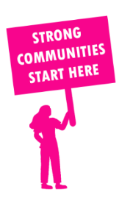
THE VALUE OF NEIGHBOURHOOD HOUSES IN ST ALBANS IN 2024

Neighbourhood Houses are the Hearts of their Communities.
11,748 visits
39 volunteers
25 jobs
Value to the electorate
per $1 of income:
$3.32
Community value provided:
$1,659,527
Here’s what participants reported:
90% said the activity they participated in had a positive or very positive impact on their emotional wellbeing,
92% said the activity they participated in had a positive or very positive impact on their physical wellbeing
87% said the activity they participated in had a positive or very positive impact on their social connections.
34% participants became more involved in community activities outside of a Neighbourhood House
80% said the activity they participated in had a positive or very positive impact on their sense of belonging.

24
community groups supported
1,704
Sessions across 3 Neighbourhood Houses
17,136 KGS
in food relief
25
NHCP funded hours/week on average
156
Hours connecting people to gov services

Neighbourhood Houses in St Albans
Cairnlea Community Hub
St Albans Community Youth Club
Cooinda Aboriginal Corporation

