
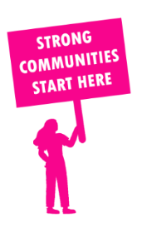
THE VALUE OF NEIGHBOURHOOD HOUSES IN TARNEIT IN 2024

Neighbourhood Houses are the Hearts of their Communities.
38,964 visits
10 volunteers
1 jobs
Value to the electorate
per $1 of income:
$3.31
Community value provided:
$5,536,518
Here’s what participants reported:
100% said the activity they participated in had a positive or very positive impact on their emotional wellbeing,
100% said the activity they participated in had a positive or very positive impact on their physical wellbeing
100% said the activity they participated in had a positive or very positive impact on their social connections.
62% participants became more involved in community activities outside of a Neighbourhood House
80% said the activity they participated in had a positive or very positive impact on their sense of belonging.

84
community groups supported
3,100
Sessions across 2 Neighbourhood Houses
2,340 KGS
in food relief
25
NHCP funded hours/week on average
12
Hours connecting people to gov services

Neighbourhood Houses in Tarneit
Tarneit Community Learning Centre
The Grange Community Centre

