
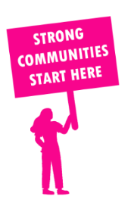
THE VALUE OF NEIGHBOURHOOD HOUSES IN PRAHRAN IN 2024

Neighbourhood Houses are the Hearts of their Communities.
8,880 visits
54 volunteers
39 jobs
Value to the electorate
per $1 of income:
$2.50
Community value provided:
$5,742,053
Here’s what participants reported:
97% said the activity they participated in had a positive or very positive impact on their emotional wellbeing,
100% said the activity they participated in had a positive or very positive impact on their physical wellbeing
96% said the activity they participated in had a positive or very positive impact on their social connections.
60% participants became more involved in community activities outside of a Neighbourhood House
75% said the activity they participated in had a positive or very positive impact on their sense of belonging.

14
community groups supported
1,730
Sessions across 2 Neighbourhood Houses
6,144 KGS
in food relief
39
NHCP funded hours/week on average
168
Hours connecting people to gov services

Neighbourhood Houses in Prahran
Port Phillip Community Group
Prahran Community Learning Centre

