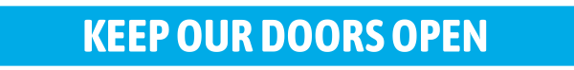
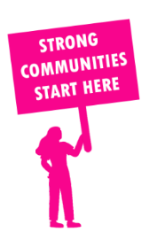
THE VALUE OF NEIGHBOURHOOD HOUSES IN PASCOE VALE IN 2024

Neighbourhood Houses are the Hearts of their Communities.
33,480 visits
193 volunteers
171 jobs
Value to the electorate
per $1 of income:
$5.84
Community value provided:
$9,871,214
Here’s what participants reported:
96% said the activity they participated in had a positive or very positive impact on their emotional wellbeing,
98% said the activity they participated in had a positive or very positive impact on their physical wellbeing
97% said the activity they participated in had a positive or very positive impact on their social connections.
66% participants became more involved in community activities outside of a Neighbourhood House
89% said the activity they participated in had a positive or very positive impact on their sense of belonging.

33
community groups supported
4,177
Sessions across 4 Neighbourhood Houses
16,620 KGS
in food relief
36.2
NHCP funded hours/week on average
144
Hours connecting people to gov services

Neighbourhood Houses in Pascoe Vale
East Coburg Neighbourhood House
Newlands Neighbourhood House
Reynard Street Neighbourhood House
Sussex Neighbourhood House

