
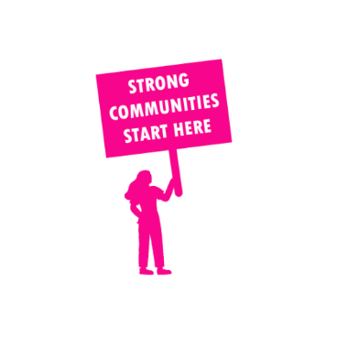
THE VALUE OF NEIGHBOURHOOD HOUSES IN WESTERN VICTORIA REGION IN 2024

Neighbourhood Houses are the Hearts of their Communities.
216,174 visits
2,328 volunteers
598 jobs
Value to the electorate
per $1 of income:
$2.32
Community value provided:
$98,636,190
Here’s what participants reported:
94% said the activity they participated in had a positive or very positive impact on their emotional wellbeing,
96% said the activity they participated in had a positive or very positive impact on their physical wellbeing
95% said the activity they participated in had a positive or very positive impact on their social connections.
62% participants became more involved in community activities outside of a Neighbourhood House
82% said the activity they participated in had a positive or very positive impact on their sense of belonging.

591
community groups supported
45,358
Sessions across 64 Neighbourhood Houses
414,636 KGS
in food relief
27.5
NHCP funded hours/week on average
8,214
Hours connecting people to gov services

Neighbourhood Houses in Western Victoria
Bellarine Training and Community Hub
Leopold Community & Learning Centre
Portarlington Neighbourhood House
Queenscliffe and District Neighbourhood House
SpringDale Neighbourhood Centre
Bellarine Living and Learning Centre
Geelong West Neighbourhood House
South Barwon Community Centre
Cloverdale Community Centre
Lara Community Centre
Norlane Community Centre
Rosewall Neighbourhood Centre
Vines Road Community Centre
Anglesea Community House
Colac Neighbourhood House
Deans Marsh Community Cottage
Forrest Neighbourhood House
Gellibrand Community House
Lorne Community House
Marrar Woorn Neighbourhood House
Torquay Community House
Winchelsea Community House
Grovedale Neighbourhood House
Anakie & District Community Group
Ballan & District Community House
Ballarat East Neighbourhood House
Darley Neighbourhood House & Learning Centre
Laurels Education and Training
Meredith Community Centre
Beaufort Community House & Learning Centre
Clunes Neighbourhood House
Creswick Neighbourhood Centre
Haddon Community Learning Centre
Ballarat Neighbourhood Centre
Ballarat North Neighbourhood House
Wendouree Neighbourhood Centre
Djerriwarrh Community and Education Services
Eynesbury Discovery Centre
Kirrip Aboriginal Corporation
Melton South Community Centre
Dunolly & District Neighbourhood Centre
Inglewood Community Neighbourhood House
Maryborough Community House
Mill House Neighbourhood House
Wedderburn Community House
Hamilton Community House
Old Courthouse Community Centre
Camperdown Community House
Simpson and District Community Centre
Port Fairy Community House

Portland Neighbourhood House
Warrnambool Neighbourhood & Community Centre
West Warrnambool Neighbourhood House
Harrow Neighbourhood House
Horsham Neighbourhood House
Kaniva LINK Neighbourhood House
Murtoa & District Neighbourhood House
Nhill Neighbourhood House Learning Centre
Rainbow Neighbourhood House
Stawell Neighbourhood House
Warracknabeal Neighbourhood House & Learning Centre
Halls Gap Neighbourhood House
Ararat Neighbourhood House
St Arnaud Neighbourhood House

