
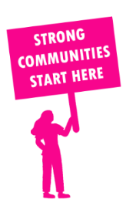
THE VALUE OF NEIGHBOURHOOD HOUSES IN POINT COOK IN 2024

Neighbourhood Houses are the Hearts of their Communities.
14,604 visits
21 volunteers
11 jobs
Value to the electorate
per $1 of income:
$5.77
Community value provided:
$3,049,953
Here’s what participants reported:
95% said the activity they participated in had a positive or very positive impact on their emotional wellbeing,
99% said the activity they participated in had a positive or very positive impact on their physical wellbeing
99% said the activity they participated in had a positive or very positive impact on their social connections.
50% participants became more involved in community activities outside of a Neighbourhood House
83% said the activity they participated in had a positive or very positive impact on their sense of belonging.

31
community groups supported
2,123
Sessions across 2 Neighbourhood Houses
36,264 KGS
in food relief
25
NHCP funded hours/week on average
144
Hours connecting people to gov services

Neighbourhood Houses in Point Cook
Altona Meadows Community Centre
Jamieson Way Community Centre (no longer functioning)
Seabrook Community Centre (Unfunded)

