
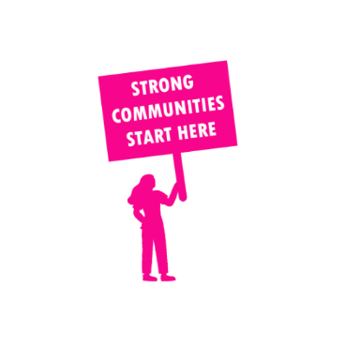
THE VALUE OF NEIGHBOURHOOD HOUSES IN NORTHERN VICTORIA REGION IN 2024

Neighbourhood Houses are the Hearts of their Communities.
240,182 visits
3,394 volunteers
711 jobs
Value to the electorate
per $1 of income:
$2.20
Community value provided:
$138,667,489
Here’s what participants reported:
92% said the activity they participated in had a positive or very positive impact on their emotional wellbeing,
95% said the activity they participated in had a positive or very positive impact on their physical wellbeing
93% said the activity they participated in had a positive or very positive impact on their social connections.
61% participants became more involved in community activities outside of a Neighbourhood House
80% said the activity they participated in had a positive or very positive impact on their sense of belonging.

649
community groups supported
57,169
Sessions across 96 Neighbourhood Houses
735,588 KGS
in food relief
25.3
NHCP funded hours/week on average
20,070
Hours connecting people to gov services

Neighbourhood Houses in Northern Victoria
Daylesford Neighbourhood Centre
Trentham Neighbourhood Centre
Cire Yarra Junction Community Hub
Healesville Living & Learning Centre
Woori Community House
Yarra Glen & District Living & Learning Centre
Alexandra Community Hub
Bonnie Doon Community Centre
Flowerdale Community House
Kinglake Ranges Neighbourhood House
Mansfield Adult Continuing Education Centre
Toolangi Castella District Community House
Yea Community House
Broadford Living and Learning Centre
Kilmore Community Centre
Nagambie Lakes Community House
Neighbourhood House Murchison
Puckapunyal & District Neighbourhood Centre
Pyalong Neighbourhood House
Seymour and District Community House
Tablelands Community Centre
Violet Town Community House
Waminda Community House
Cobram Community House
Mooroopna Education & Activity Centre
Nathalia & District Community Association
North Shepparton Community & Learning Centre
Numurkah Community Learning Centre
South Shepparton Community Centre
Tatura Community House
Birchip Neighbourhood House
Charlton Neighbourhood House
Donald Learning Group
Mildura Community House
Murrayville Neighbourhood House
Ouyen Neighbourhood House
Red Cliffs Community Resource Centre
Robinvale Network House
Sea Lake & District Neighbourhood House
Wycheproof Community Resource Centre
Cohuna Neighbourhood House
Kerang & District Community Centre
Quambatook Community Resource Centre
Swan Hill Neighbourhood House
Allwood Neighbourhood House
Living and Learning Nillumbik - Panton Hill
Wadambuk St Andrews Community Centre
Mernda Community House
Whittlesea Community House
Bendigo Neighbourhood Hub

Eaglehawk Community House
Huntly Community Hub
Old Church on the Hill
Castlemaine Community House
Kangaroo Flat Community House
Long Gully Neighbourhood Centre
Maldon Neighbourhood Centre
Marong Neighbourhood House
Nalderun Education Aboriginal Corporation
Girgarre Community Cottage
Heathcote Community House
Rushworth Community House
Kyneton Community House
Lancefield Neighbourhood House
Macedon and Mount Macedon Community House
Macedon Ranges Further Education Centre
Riddells Creek Neighbourhood House
Romsey Neighbourhood House
Woodend Neighbourhood House
Boort Resource and Information Centre
Crossenvale Community House
Echuca Neighbourhood House
Kyabram Community & Learning Centre
Lockington District Business Centre
Pyramid Hill Neighbourhood House
Rochester Community House
Tongala Community Activities Centre
Aldara Yenara Aboriginal Corporation
Bandiana Neighbourhood House
Baranduda Community Centre
Birallee Park Neighbourhood House
Chiltern Neighbourhood House
Corryong Neighbourhood Centre
Felltimber Community Centre
Quercus Beechworth
Tallangatta Neighbourhood House
Trudewind Neighbourhood House
Yackandandah Community Centre
King Valley Learning Exchange
Mount Beauty Neighbourhood Centre
Myrtleford Neighbourhood Centre
Open Door Neighbourhood House
Pangerang Community House
Yarrawonga Neighbourhood House
Hopetoun & District Neighbourhood House
Harcourt Valley Community House

Includes 9 unfunded Neighbourhood Houses

