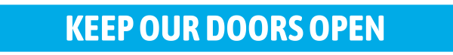
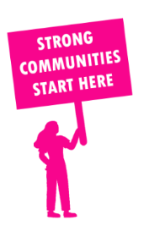
THE VALUE OF NEIGHBOURHOOD HOUSES IN OVENS VALLEY IN 2024

Neighbourhood Houses are the Hearts of their Communities.
15,816 visits
219 volunteers
173 jobs
Value to the electorate
per $1 of income:
$5.68
Community value provided:
$18,989,295
Here’s what participants reported:
87% said the activity they participated in had a positive or very positive impact on their emotional wellbeing,
90% said the activity they participated in had a positive or very positive impact on their physical wellbeing
86% said the activity they participated in had a positive or very positive impact on their social connections.
47% participants became more involved in community activities outside of a Neighbourhood House
71% said the activity they participated in had a positive or very positive impact on their sense of belonging.

37
community groups supported
5,277
Sessions across 7 Neighbourhood Houses
76,404 KGS
in food relief
27.1
NHCP funded hours/week on average
4,578
Hours connecting people to gov services

Neighbourhood Houses in Ovens Valley
Cobram Community House
King Valley Learning Exchange
Mount Beauty Neighbourhood Centre
Myrtleford Neighbourhood Centre
Open Door Neighbourhood House
Pangerang Community House
Yarrawonga Neighbourhood House

