
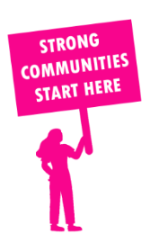
THE VALUE OF NEIGHBOURHOOD HOUSES IN NEPEAN IN 2024

Neighbourhood Houses are the Hearts of their Communities.
18,300 visits
190 volunteers
159 jobs
Value to the electorate
per $1 of income:
$2.62
Community value provided:
$7,448,936
Here’s what participants reported:
97% said the activity they participated in had a positive or very positive impact on their emotional wellbeing,
97% said the activity they participated in had a positive or very positive impact on their physical wellbeing
97% said the activity they participated in had a positive or very positive impact on their social connections.
60% participants became more involved in community activities outside of a Neighbourhood House
75% said the activity they participated in had a positive or very positive impact on their sense of belonging.

48
community groups supported
6,209
Sessions across 4 Neighbourhood Houses
48,744 KGS
in food relief
25
NHCP funded hours/week on average
60
Hours connecting people to gov services

Neighbourhood Houses in Nepean
Dromana Community House
Rye Community House
Seawinds Community Hub
Sorrento Community Centre

