
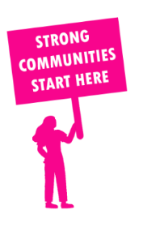
THE VALUE OF NEIGHBOURHOOD HOUSES IN THOMASTOWN IN 2024

Neighbourhood Houses are the Hearts of their Communities.
8,388 visits
107 volunteers
84 jobs
Value to the electorate
per $1 of income:
$4.66
Community value provided:
$5,048,407
Here’s what participants reported:
95% said the activity they participated in had a positive or very positive impact on their emotional wellbeing,
96% said the activity they participated in had a positive or very positive impact on their physical wellbeing
95% said the activity they participated in had a positive or very positive impact on their social connections.
62% participants became more involved in community activities outside of a Neighbourhood House
80% said the activity they participated in had a positive or very positive impact on their sense of belonging.

21
community groups supported
3,758
Sessions across 3 Neighbourhood Houses
49,668 KGS
in food relief
25
NHCP funded hours/week on average
408
Hours connecting people to gov services

Neighbourhood Houses in Thomastown
Creeds Farm Living and Learning Centre
Lalor Living and Learning Centre
Thomastown Neighbourhood House

