
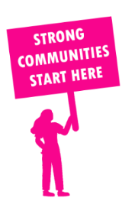
THE VALUE OF NEIGHBOURHOOD HOUSES IN ELTHAM IN 2024

Neighbourhood Houses are the Hearts of their Communities.
15,660 visits
96 volunteers
77 jobs
Value to the electorate
per $1 of income:
$3.92
Community value provided:
$5,506,570
Here’s what participants reported:
89% said the activity they participated in had a positive or very positive impact on their emotional wellbeing,
97% said the activity they participated in had a positive or very positive impact on their physical wellbeing
95% said the activity they participated in had a positive or very positive impact on their social connections.
56% participants became more involved in community activities outside of a Neighbourhood House
71% said the activity they participated in had a positive or very positive impact on their sense of belonging.

20
community groups supported
3,678
Sessions across 3 Neighbourhood Houses
52,560 KGS
in food relief
25
NHCP funded hours/week on average
276
Hours connecting people to gov services

Neighbourhood Houses in Eltham
Greenhills Neighbourhood House
Living and Learning Nillumbik - Diamond Creek
Living and Learning Nillumbik - Eltham

