
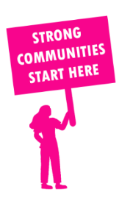
THE VALUE OF NEIGHBOURHOOD HOUSES IN MONBULK IN 2024

Neighbourhood Houses are the Hearts of their Communities.
22,320 visits
155 volunteers
120 jobs
Value to the electorate
per $1 of income:
$5.40
Community value provided:
$20,424,473
Here’s what participants reported:
96% said the activity they participated in had a positive or very positive impact on their emotional wellbeing,
98% said the activity they participated in had a positive or very positive impact on their physical wellbeing
95% said the activity they participated in had a positive or very positive impact on their social connections.
60% participants became more involved in community activities outside of a Neighbourhood House
75% said the activity they participated in had a positive or very positive impact on their sense of belonging.

32
community groups supported
8,004
Sessions across 6 Neighbourhood Houses
3,084 KGS
in food relief
25
NHCP funded hours/week on average
264
Hours connecting people to gov services

Neighbourhood Houses in Monbulk
Cockatoo Community House
Coonara Community House
Fernlea Community House
Mountain District Learning Centre
Olinda Community House
Selby Community House
The Basin Community House

