
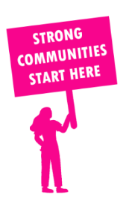
THE VALUE OF NEIGHBOURHOOD HOUSES IN WENDOUREE IN 2024

Neighbourhood Houses are the Hearts of their Communities.
18,000 visits
144 volunteers
126 jobs
Value to the electorate
per $1 of income:
$4.98
Community value provided:
$8,025,827
Here’s what participants reported:
97% said the activity they participated in had a positive or very positive impact on their emotional wellbeing,
96% said the activity they participated in had a positive or very positive impact on their physical wellbeing
89% said the activity they participated in had a positive or very positive impact on their social connections.
59% participants became more involved in community activities outside of a Neighbourhood House
77% said the activity they participated in had a positive or very positive impact on their sense of belonging.

39
community groups supported
1,920
Sessions across 3 Neighbourhood Houses
20,580 KGS
in food relief
31.7
NHCP funded hours/week on average
384
Hours connecting people to gov services

Neighbourhood Houses in Wendouree
Ballarat Neighbourhood Centre
Ballarat North Neighbourhood House
Wendouree Neighbourhood Centre

