
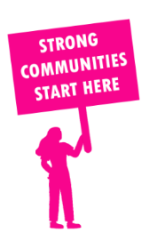
THE VALUE OF NEIGHBOURHOOD HOUSES IN OAKLEIGH IN 2024

Neighbourhood Houses are the Hearts of their Communities.
11,820 visits
222 volunteers
208 jobs
Value to the electorate
per $1 of income:
$5.81
Community value provided:
$3,062,153
Here’s what participants reported:
96% said the activity they participated in had a positive or very positive impact on their emotional wellbeing,
98% said the activity they participated in had a positive or very positive impact on their physical wellbeing
98% said the activity they participated in had a positive or very positive impact on their social connections.
71% participants became more involved in community activities outside of a Neighbourhood House
83% said the activity they participated in had a positive or very positive impact on their sense of belonging.

9
community groups supported
1,693
Sessions across 3 Neighbourhood Houses
12,024 KGS
in food relief
25
NHCP funded hours/week on average
84
Hours connecting people to gov services

Neighbourhood Houses in Oakleigh
Dixon House Neighbourhood Centre
Fusion Oakleigh Youth & Community Centre
Notting Hill Neighbourhood House

