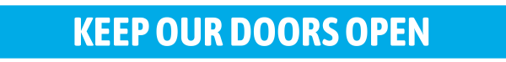
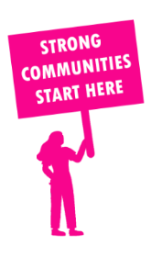
THE VALUE OF NEIGHBOURHOOD HOUSES IN WERRIBEE IN 2024

Neighbourhood Houses are the Hearts of their Communities.
126,768 visits
229 volunteers
174 jobs
Value to the electorate
per $1 of income:
$1.79
Community value provided:
$36,240,518
Here’s what participants reported:
87% said the activity they participated in had a positive or very positive impact on their emotional wellbeing,
94% said the activity they participated in had a positive or very positive impact on their physical wellbeing
92% said the activity they participated in had a positive or very positive impact on their social connections.
52% participants became more involved in community activities outside of a Neighbourhood House
84% said the activity they participated in had a positive or very positive impact on their sense of belonging.

182
community groups supported
19,939
Sessions across 5 Neighbourhood Houses
39,024 KGS
in food relief
27.5
NHCP funded hours/week on average
2,388
Hours connecting people to gov services

Neighbourhood Houses in Werribee
Iramoo Community Centre
Koling wada-ngal
Quantin Binnah Community Centre
Wyndham Community and Education Centre
Wyndham Park Community Centre

