
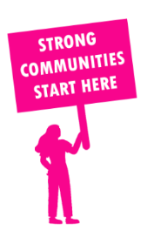
THE VALUE OF NEIGHBOURHOOD HOUSES IN KALKALLO IN 2024

Neighbourhood Houses are the Hearts of their Communities.
3,744 visits
25 volunteers
10 jobs
Value to the electorate
per $1 of income:
$5.52
Community value provided:
$1,931,566
Here’s what participants reported:
99% said the activity they participated in had a positive or very positive impact on their emotional wellbeing,
99% said the activity they participated in had a positive or very positive impact on their physical wellbeing
99% said the activity they participated in had a positive or very positive impact on their social connections.
48% participants became more involved in community activities outside of a Neighbourhood House
84% said the activity they participated in had a positive or very positive impact on their sense of belonging.

14
community groups supported
3,121
Sessions across 2 Neighbourhood Houses
2,676 KGS
in food relief
30
NHCP funded hours/week on average
540
Hours connecting people to gov services

Neighbourhood Houses in Kalkallo
Craigieburn Education & Community Centre
Wallan & District Community Group

