
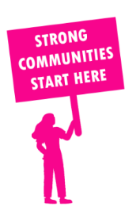
THE VALUE OF NEIGHBOURHOOD HOUSES IN CLARINDA IN 2024

Neighbourhood Houses are the Hearts of their Communities.
48,420 visits
73 volunteers
61 jobs
Value to the electorate
per $1 of income:
$5.60
Community value provided:
$12,570,955
Here’s what participants reported:
94% said the activity they participated in had a positive or very positive impact on their emotional wellbeing,
96% said the activity they participated in had a positive or very positive impact on their physical wellbeing
95% said the activity they participated in had a positive or very positive impact on their social connections.
53% participants became more involved in community activities outside of a Neighbourhood House
78% said the activity they participated in had a positive or very positive impact on their sense of belonging.

42
community groups supported
3,994
Sessions across 4 Neighbourhood Houses
10,056 KGS
in food relief
28.8
NHCP funded hours/week on average
540
Hours connecting people to gov services

Neighbourhood Houses in Clarinda
Dingley Village Neighbourhood Centre
Keysborough Learning Centre
Sundowner Community Centre
Westall Community Hub

