
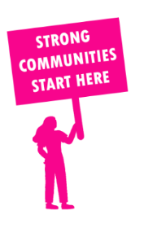
THE VALUE OF NEIGHBOURHOOD HOUSES IN MORWELL IN 2024

Neighbourhood Houses are the Hearts of their Communities.
14,100 visits
98 volunteers
71 jobs
Value to the electorate
per $1 of income:
$5.42
Community value provided:
$6,726,031
Here’s what participants reported:
91% said the activity they participated in had a positive or very positive impact on their emotional wellbeing,
93% said the activity they participated in had a positive or very positive impact on their physical wellbeing
94% said the activity they participated in had a positive or very positive impact on their social connections.
46% participants became more involved in community activities outside of a Neighbourhood House
69% said the activity they participated in had a positive or very positive impact on their sense of belonging.

34
community groups supported
3,270
Sessions across 4 Neighbourhood Houses
78,024 KGS
in food relief
33.3
NHCP funded hours/week on average
264
Hours connecting people to gov services

Neighbourhood Houses in Morwell
Churchill Neighbourhood Centre
Moe Neighbourhood House
Morwell Neighbourhood House
Traralgon Neighbourhood Learning House

