
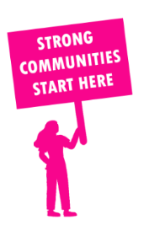
THE VALUE OF NEIGHBOURHOOD HOUSES IN GEELONG IN 2024

Neighbourhood Houses are the Hearts of their Communities.
14,268 visits
49 volunteers
24 jobs
Value to the electorate
per $1 of income:
$5.07
Community value provided:
$3,279,339
Here’s what participants reported:
97% said the activity they participated in had a positive or very positive impact on their emotional wellbeing,
99% said the activity they participated in had a positive or very positive impact on their physical wellbeing
96% said the activity they participated in had a positive or very positive impact on their social connections.
49% participants became more involved in community activities outside of a Neighbourhood House
66% said the activity they participated in had a positive or very positive impact on their sense of belonging.

49
community groups supported
2,439
Sessions across 3 Neighbourhood Houses
12,396 KGS
in food relief
26.7
NHCP funded hours/week on average
828
Hours connecting people to gov services

Neighbourhood Houses in Geelong
Bellarine Living and Learning Centre
Geelong West Neighbourhood House
South Barwon Community Centre

