
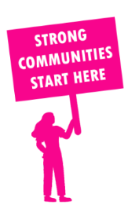
THE VALUE OF NEIGHBOURHOOD HOUSES IN BULLEEN IN 2024

Neighbourhood Houses are the Hearts of their Communities.
14,748 visits
81 volunteers
67 jobs
Value to the electorate
per $1 of income:
$6.23
Community value provided:
$14,829,251
Here’s what participants reported:
90% said the activity they participated in had a positive or very positive impact on their emotional wellbeing,
93% said the activity they participated in had a positive or very positive impact on their physical wellbeing
90% said the activity they participated in had a positive or very positive impact on their social connections.
44% participants became more involved in community activities outside of a Neighbourhood House
63% said the activity they participated in had a positive or very positive impact on their sense of belonging.

5
community groups supported
3,657
Sessions across 2 Neighbourhood Houses
15,948 KGS
in food relief
25
NHCP funded hours/week on average
24
Hours connecting people to gov services

Neighbourhood Houses in Bulleen
Living and Learning @ Ajani
Pines Learning

