
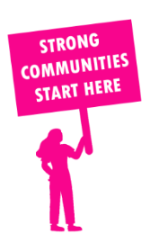
THE VALUE OF NEIGHBOURHOOD HOUSES IN BENTLEIGH IN 2024

Neighbourhood Houses are the Hearts of their Communities.
20,676 visits
238 volunteers
212 jobs
Value to the electorate
per $1 of income:
$5.99
Community value provided:
$12,357,399
Here’s what participants reported:
93% said the activity they participated in had a positive or very positive impact on their emotional wellbeing,
98% said the activity they participated in had a positive or very positive impact on their physical wellbeing
97% said the activity they participated in had a positive or very positive impact on their social connections.
56% participants became more involved in community activities outside of a Neighbourhood House
83% said the activity they participated in had a positive or very positive impact on their sense of belonging.

17
community groups supported
5,492
Sessions across 3 Neighbourhood Houses
2,448 KGS
in food relief
26.7
NHCP funded hours/week on average
159
Hours connecting people to gov services

Neighbourhood Houses in Bentleigh
Cheltenham Community Centre
Godfrey Street Community House
Moongala Women's Community House

