
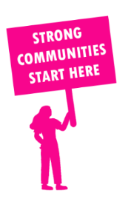
THE VALUE OF NEIGHBOURHOOD HOUSES IN HAWTHORN IN 2024

Neighbourhood Houses are the Hearts of their Communities.
36,450 visits
238 volunteers
208 jobs
Value to the electorate
per $1 of income:
$2.99
Community value provided:
$7,213,262
Here’s what participants reported:
94% said the activity they participated in had a positive or very positive impact on their emotional wellbeing,
97% said the activity they participated in had a positive or very positive impact on their physical wellbeing
95% said the activity they participated in had a positive or very positive impact on their social connections.
47% participants became more involved in community activities outside of a Neighbourhood House
77% said the activity they participated in had a positive or very positive impact on their sense of belonging.

75
community groups supported
7,586
Sessions across 4 Neighbourhood Houses
16,164 KGS
in food relief
20
NHCP funded hours/week on average
1,056
Hours connecting people to gov services

Neighbourhood Houses in Hawthorn
Bowen Street Community Centre
Camberwell Community Centre (Unfunded)
Canterbury Neighbourhood Centre
Hawthorn Community House
Surrey Hills Neighbourhood Centre

