
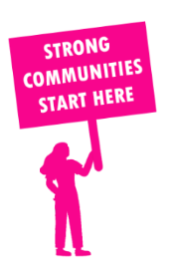
THE VALUE OF NEIGHBOURHOOD HOUSES IN RICHMOND IN 2024

Neighbourhood Houses are the Hearts of their Communities.
27,204 visits
228 volunteers
197 jobs
Value to the electorate
per $1 of income:
$2.32
Community value provided:
$8,229,967
Here’s what participants reported:
98% said the activity they participated in had a positive or very positive impact on their emotional wellbeing,
100% said the activity they participated in had a positive or very positive impact on their physical wellbeing
98% said the activity they participated in had a positive or very positive impact on their social connections.
75% participants became more involved in community activities outside of a Neighbourhood House
88% said the activity they participated in had a positive or very positive impact on their sense of belonging.

33
community groups supported
6,431
Sessions across 5 Neighbourhood Houses
5,184 KGS
in food relief
26
NHCP funded hours/week on average
480
Hours connecting people to gov services

Neighbourhood Houses in Richmond
Belgium Avenue Neighbourhood House
Collingwood Neighbourhood House
Finbar Neighbourhood House
Fitzroy Learning Network
Richmond Community Learning Centre

