
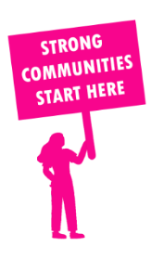
THE VALUE OF NEIGHBOURHOOD HOUSES IN BOX HILL IN 2024

Neighbourhood Houses are the Hearts of their Communities.
28,344 visits
222 volunteers
167 jobs
Value to the electorate
per $1 of income:
$5.14
Community value provided:
$12,904,890
Here’s what participants reported:
97% said the activity they participated in had a positive or very positive impact on their emotional wellbeing,
98% said the activity they participated in had a positive or very positive impact on their physical wellbeing
98% said the activity they participated in had a positive or very positive impact on their social connections.
71% participants became more involved in community activities outside of a Neighbourhood House
89% said the activity they participated in had a positive or very positive impact on their sense of belonging.

47
community groups supported
7,537
Sessions across 7 Neighbourhood Houses
1,236 KGS
in food relief
25
NHCP funded hours/week on average
384
Hours connecting people to gov services

Neighbourhood Houses in Box Hill
Avenue Neighbourhood House @ Eley
Bennettswood Neighbourhood House
Box Hill South Neighbourhood House
Clota Cottage Neighbourhood House
Kerrimuir Neighbourhood House
Koonung Cottage Community House
Louise Multicultural Community Centre

