
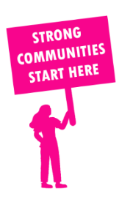
THE VALUE OF NEIGHBOURHOOD HOUSES IN WARRANDYTE IN 2024

Neighbourhood Houses are the Hearts of their Communities.
39,540 visits
156 volunteers
128 jobs
Value to the electorate
per $1 of income:
$8.39
Community value provided:
$2,0703,125
Here’s what participants reported:
94% said the activity they participated in had a positive or very positive impact on their emotional wellbeing,
94% said the activity they participated in had a positive or very positive impact on their physical wellbeing
92% said the activity they participated in had a positive or very positive impact on their social connections.
44% participants became more involved in community activities outside of a Neighbourhood House
69% said the activity they participated in had a positive or very positive impact on their sense of belonging.

61
community groups supported
7,000
Sessions across 5 Neighbourhood Houses
8,436 KGS
in food relief
25
NHCP funded hours/week on average
204
Hours connecting people to gov services

Neighbourhood Houses in Warrandyte
Cire Chirnside Park Community Hub
North Ringwood Community House
Park Orchards Learning Centre
Warrandyte Neighbourhood House
Wonga Park Community Cottage

