
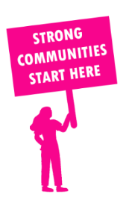
THE VALUE OF NEIGHBOURHOOD HOUSES IN KOROROIT IN 2024

Neighbourhood Houses are the Hearts of their Communities.
20,124 visits
41 volunteers
38 jobs
Value to the electorate
per $1 of income:
$1.64
Community value provided:
$16,379,456
Here’s what participants reported:
95% said the activity they participated in had a positive or very positive impact on their emotional wellbeing,
98% said the activity they participated in had a positive or very positive impact on their physical wellbeing
95% said the activity they participated in had a positive or very positive impact on their social connections.
60% participants became more involved in community activities outside of a Neighbourhood House
82% said the activity they participated in had a positive or very positive impact on their sense of belonging.

51
community groups supported
3,186
Sessions across 4 Neighbourhood Houses
n/a KGS
in food relief
28.8
NHCP funded hours/week on average
228
Hours connecting people to gov services

Neighbourhood Houses in Kororoit
Comm Unity Plus Services Ltd
Hunt Club Community & Arts Centre
Stevenson House
Westvale Community Centre

