
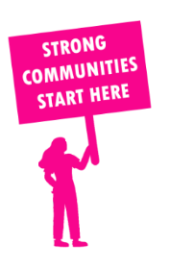
THE VALUE OF NEIGHBOURHOOD HOUSES IN BRUNSWICK IN 2024

Neighbourhood Houses are the Hearts of their Communities.
23,724 visits
262 volunteers
229 jobs
Value to the electorate
per $1 of income:
$4.58
Community value provided:
$12,460,304
Here’s what participants reported:
95% said the activity they participated in had a positive or very positive impact on their emotional wellbeing,
99% said the activity they participated in had a positive or very positive impact on their physical wellbeing
96% said the activity they participated in had a positive or very positive impact on their social connections.
59% participants became more involved in community activities outside of a Neighbourhood House
84% said the activity they participated in had a positive or very positive impact on their sense of belonging.

15
community groups supported
5,209
Sessions across 4 Neighbourhood Houses
9,180 KGS
in food relief
28.2
NHCP funded hours/week on average
816
Hours connecting people to gov services

Neighbourhood Houses in Brunswick
Brunswick Neighbourhood House
Holden Street Neighbourhood House
Princes Hill Community Centre (Unfunded)
Carlton Neighbourhood Learning Centre

