
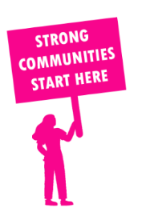
THE VALUE OF NEIGHBOURHOOD HOUSES IN BERWICK IN 2024

Neighbourhood Houses are the Hearts of their Communities.
44,808 visits
69 volunteers
37 jobs
Value to the electorate
per $1 of income:
$3.10
Community value provided:
$7,708,769
Here’s what participants reported:
97% said the activity they participated in had a positive or very positive impact on their emotional wellbeing,
99% said the activity they participated in had a positive or very positive impact on their physical wellbeing
99% said the activity they participated in had a positive or very positive impact on their social connections.
44% participants became more involved in community activities outside of a Neighbourhood House
71% said the activity they participated in had a positive or very positive impact on their sense of belonging.

50
community groups supported
5,087
Sessions across 4 Neighbourhood Houses
16,956 KGS
in food relief
25
NHCP funded hours/week on average
96
Hours connecting people to gov services

Neighbourhood Houses in Berwick
Beaconsfield Neighbourhood Centre
Berwick Neighbourhood Centre
Brentwood Park Neighbourhood House
Upper Beaconsfield Community Centre

