
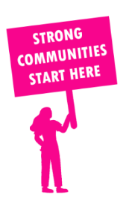
THE VALUE OF NEIGHBOURHOOD HOUSES IN ROWVILLE IN 2024

Neighbourhood Houses are the Hearts of their Communities.
1,656 visits
10 volunteers
6 jobs
Value to the electorate
per $1 of income:
$7.03
Community value provided:
$2,276,473
Here’s what participants reported:
83% said the activity they participated in had a positive or very positive impact on their emotional wellbeing,
100% said the activity they participated in had a positive or very positive impact on their physical wellbeing
100% said the activity they participated in had a positive or very positive impact on their social connections.
61% participants became more involved in community activities outside of a Neighbourhood House
80% said the activity they participated in had a positive or very positive impact on their sense of belonging.

6
community groups supported
898
Sessions
n/a KGS
in food relief
25
NHCP funded hours/week on average
144
Hours connecting people to gov services

Neighbourhood Houses in Rowville
Rowville Neighbourhood Learning Centre (Community Learning Centre)

