
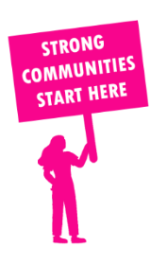
THE VALUE OF NEIGHBOURHOOD HOUSES IN GREENVALE IN 2024

Neighbourhood Houses are the Hearts of their Communities.
12,852 visits
58 volunteers
39 jobs
Value to the electorate
per $1 of income:
$3.29
Community value provided:
$2,161,072
Here’s what participants reported:
94% said the activity they participated in had a positive or very positive impact on their emotional wellbeing,
94% said the activity they participated in had a positive or very positive impact on their physical wellbeing
97% said the activity they participated in had a positive or very positive impact on their social connections.
59% participants became more involved in community activities outside of a Neighbourhood House
81% said the activity they participated in had a positive or very positive impact on their sense of belonging.

24
community groups supported
1,832
Sessions across 3 Neighbourhood Houses
10,200 KGS
in food relief
30
NHCP funded hours/week on average
372
Hours connecting people to gov services

Neighbourhood Houses in Greenvale
Attwood House Community Centre
Homestead Community and Learning Centre
Kenley Court Neighbourhood House

