
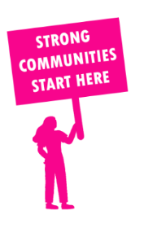
THE VALUE OF NEIGHBOURHOOD HOUSES IN EUROA IN 2024

Neighbourhood Houses are the Hearts of their Communities.
18,600 visits
338 volunteers
240 jobs
Value to the electorate
per $1 of income:
$3.48
Community value provided:
$7,509,752
Here’s what participants reported:
93% said the activity they participated in had a positive or very positive impact on their emotional wellbeing,
95% said the activity they participated in had a positive or very positive impact on their physical wellbeing
96% said the activity they participated in had a positive or very positive impact on their social connections.
67% participants became more involved in community activities outside of a Neighbourhood House
85% said the activity they participated in had a positive or very positive impact on their sense of belonging.

64
community groups supported
6,463
Sessions across 12 Neighbourhood Houses
64,404 KGS
in food relief
25.4
NHCP funded hours/week on average
744
Hours connecting people to gov services

Neighbourhood Houses in Euroa
Broadford Living and Learning Centre
Girgarre Community Cottage
Heathcote Community House
Kilmore Community Centre
Nagambie Lakes Community House
Neighbourhood House Murchison
Puckapunyal & District Neighbourhood Centre
Pyalong Neighbourhood House
Rushworth Community House
Seymour and District Community House
Tablelands Community Centre (Unfunded)
Violet Town Community House
Waminda Community House

