
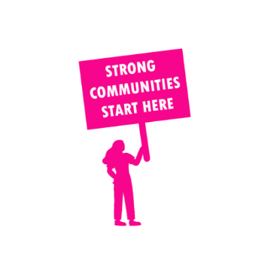
THE VALUE OF NEIGHBOURHOOD HOUSES IN BENDIGO EAST IN 2024

Neighbourhood Houses are the Hearts of their Communities.
10,980 visits
120 volunteers
99 jobs
Value to the electorate
per $1 of income:
$8.19
Community value provided:
$3,910,590
Here’s what participants reported:
99% said the activity they participated in had a positive or very positive impact on their emotional wellbeing,
100% said the activity they participated in had a positive or very positive impact on their physical wellbeing
99% said the activity they participated in had a positive or very positive impact on their social connections.
57% participants became more involved in community activities outside of a Neighbourhood House
92% said the activity they participated in had a positive or very positive impact on their sense of belonging.

38
community groups supported
1,366
Sessions across 3 Neighbourhood Houses
47,280 KGS
in food relief
18.3
NHCP funded hours/week on average
720
Hours connecting people to gov services

Neighbourhood Houses in Bendigo East
Bendigo Neighbourhood Hub
Eaglehawk Community House
Huntly Community Hub (Unfunded)
Old Church on the Hill (Unfunded)

