
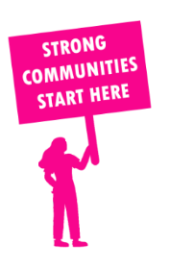
THE VALUE OF NEIGHBOURHOOD HOUSES IN MACEDON IN 2024

Neighbourhood Houses are the Hearts of their Communities.
37,920 visits
403 volunteers
347 jobs
Value to the electorate
per $1 of income:
$5.20
Community value provided:
$13,979,677
Here’s what participants reported:
92% said the activity they participated in had a positive or very positive impact on their emotional wellbeing,
94% said the activity they participated in had a positive or very positive impact on their physical wellbeing
90% said the activity they participated in had a positive or very positive impact on their social connections.
58% participants became more involved in community activities outside of a Neighbourhood House
80% said the activity they participated in had a positive or very positive impact on their sense of belonging.

76
community groups supported
5,002
Sessions across 8 Neighbourhood Houses
113,700 KGS
in food relief
25.6
NHCP funded hours/week on average
540
Hours connecting people to gov services

Neighbourhood Houses in Macedon
Daylesford Neighbourhood Centre
Kyneton Community House
Lancefield Neighbourhood House
Macedon and Mount Macedon Community House (Unfunded)
Macedon Ranges Further Education Centre
Riddells Creek Neighbourhood House
Romsey Neighbourhood House
Trentham Neighbourhood Centre
Woodend Neighbourhood House

