
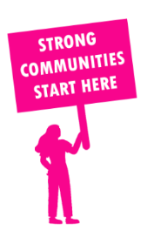
THE VALUE OF NEIGHBOURHOOD HOUSES IN SUNBURY IN 2024

Neighbourhood Houses are the Hearts of their Communities.
17,904 visits
86 volunteers
61 jobs
Value to the electorate
per $1 of income:
$4.92
Community value provided:
$4,401,769
Here’s what participants reported:
96% said the activity they participated in had a positive or very positive impact on their emotional wellbeing,
100% said the activity they participated in had a positive or very positive impact on their physical wellbeing
100% said the activity they participated in had a positive or very positive impact on their social connections.
66% participants became more involved in community activities outside of a Neighbourhood House
89% said the activity they participated in had a positive or very positive impact on their sense of belonging.

25
community groups supported
2,727
Sessions across 3 Neighbourhood Houses
26,928 KGS
in food relief
28.3
NHCP funded hours/week on average
336
Hours connecting people to gov services

Neighbourhood Houses in Sunbury
Goonawarra Neighbourhood House
Sunbury Neighbourhood House
Tullamarine Community House and Men's Shed

