
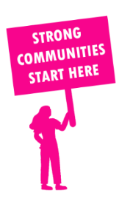
THE VALUE OF NEIGHBOURHOOD HOUSES IN CRANBOURNE IN 2024

Neighbourhood Houses are the Hearts of their Communities.
33,120 visits
61 volunteers
46 jobs
Value to the electorate
per $1 of income:
$6.80
Community value provided:
$5,466,798
Here’s what participants reported:
97% said the activity they participated in had a positive or very positive impact on their emotional wellbeing,
95% said the activity they participated in had a positive or very positive impact on their physical wellbeing
94% said the activity they participated in had a positive or very positive impact on their social connections.
74% participants became more involved in community activities outside of a Neighbourhood House
87% said the activity they participated in had a positive or very positive impact on their sense of belonging.

62
community groups supported
3,299
Sessions across 2 Neighbourhood Houses
6,672 KGS
in food relief
27.5
NHCP funded hours/week on average
756
Hours connecting people to gov services

Neighbourhood Houses in Cranbourne
Balla Balla Community Centre
Cranbourne Community House

