
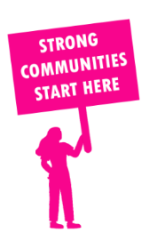
THE VALUE OF NEIGHBOURHOOD HOUSES IN HASTINGS IN 2024

Neighbourhood Houses are the Hearts of their Communities.
27,384 visits
155 volunteers
115 jobs
Value to the electorate
per $1 of income:
$2.45
Community value provided:
$6,844,167
Here’s what participants reported:
94% said the activity they participated in had a positive or very positive impact on their emotional wellbeing,
99% said the activity they participated in had a positive or very positive impact on their physical wellbeing
96% said the activity they participated in had a positive or very positive impact on their social connections.
56% participants became more involved in community activities outside of a Neighbourhood House
86% said the activity they participated in had a positive or very positive impact on their sense of belonging.

56
community groups supported
5,123
Sessions across 6 Neighbourhood Houses
42,456 KGS
in food relief
25
NHCP funded hours/week on average
744
Hours connecting people to gov services

Neighbourhood Houses in Hastings
Crib Point Community House
Good Shepherd Community House @ Wallaroo Community Centre
Hastings Community House
Langwarrin Community Centre
Somerville Community House
Willum Warrain Aboriginal Association

