
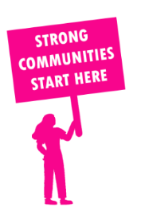
THE VALUE OF NEIGHBOURHOOD HOUSES IN LAVERTON IN 2024

Neighbourhood Houses are the Hearts of their Communities.
50,724 visits
306 volunteers
287 jobs
Value to the electorate
per $1 of income:
$5.00
Community value provided:
$39,724,983
Here’s what participants reported:
94% said the activity they participated in had a positive or very positive impact on their emotional wellbeing,
97% said the activity they participated in had a positive or very positive impact on their physical wellbeing
96% said the activity they participated in had a positive or very positive impact on their social connections.
64% participants became more involved in community activities outside of a Neighbourhood House
86% said the activity they participated in had a positive or very positive impact on their sense of belonging.

40
community groups supported
12,781
Sessions across 5 Neighbourhood Houses
125,328 KGS
in food relief
23
NHCP funded hours/week on average
792
Hours connecting people to gov services

Neighbourhood Houses in Laverton
Braybrook Community Hub
Duke Street Community House
Kororoit Creek Neighbourhood House
Laverton Community Integrated Services
West Sunshine Community Centre
Filipino Community Council of Victoria Incorporated (Unfunded)

