
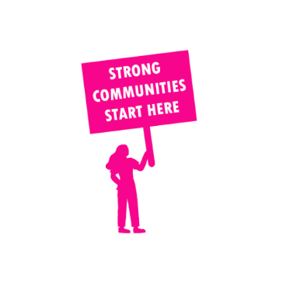
THE VALUE OF NEIGHBOURHOOD HOUSES IN ASHWOOD IN 2024

Neighbourhood Houses are the Hearts of their Communities.
41,028 visits
243 volunteers
188 jobs
Value to the electorate
per $1 of income:
$3.55
Community value provided:
$12,630,315
Here’s what participants reported:
96% said the activity they participated in had a positive or very positive impact on their emotional wellbeing,
98% said the activity they participated in had a positive or very positive impact on their physical wellbeing
96% said the activity they participated in had a positive or very positive impact on their social connections.
55% participants became more involved in community activities outside of a Neighbourhood House
76% said the activity they participated in had a positive or very positive impact on their sense of belonging.

55
community groups supported
8,405
Sessions across 7 Neighbourhood Houses
34,308 KGS
in food relief
27.5
NHCP funded hours/week on average
1,332
Hours connecting people to gov services

Neighbourhood Houses in Ashwood
Alamein Neighbourhood and Learning Centre
Amaroo Neighbourhood Centre
Ashburton Community Centre (Unfunded)
Burwood Neighbourhood House
Craig Family Centre
Power Neighbourhood House
Waverley Community Learning Centre

