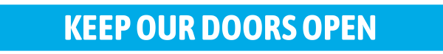
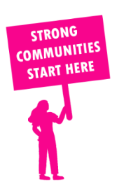
THE VALUE OF NEIGHBOURHOOD HOUSES IN SOUTH-WEST COAST IN 2024

Neighbourhood Houses are the Hearts of their Communities.
5,736 visits
94 volunteers
70 jobs
Value to the electorate
per $1 of income:
$3.52
Community value provided:
$2,141,913
Here’s what participants reported:
96% said the activity they participated in had a positive or very positive impact on their emotional wellbeing,
97% said the activity they participated in had a positive or very positive impact on their physical wellbeing
97% said the activity they participated in had a positive or very positive impact on their social connections.
61% participants became more involved in community activities outside of a Neighbourhood House
71% said the activity they participated in had a positive or very positive impact on their sense of belonging.

56
community groups supported
1,829
Sessions across 4 Neighbourhood Houses
29,460 KGS
in food relief
27.5
NHCP funded hours/week on average
300
Hours connecting people to gov services

Neighbourhood Houses in South-West Coast
Port Fairy Community House
Portland Neighbourhood House
Warrnambool Neighbourhood & Community Centre
West Warrnambool Neighbourhood House

